The main sales screen where user key in the data from the customer.
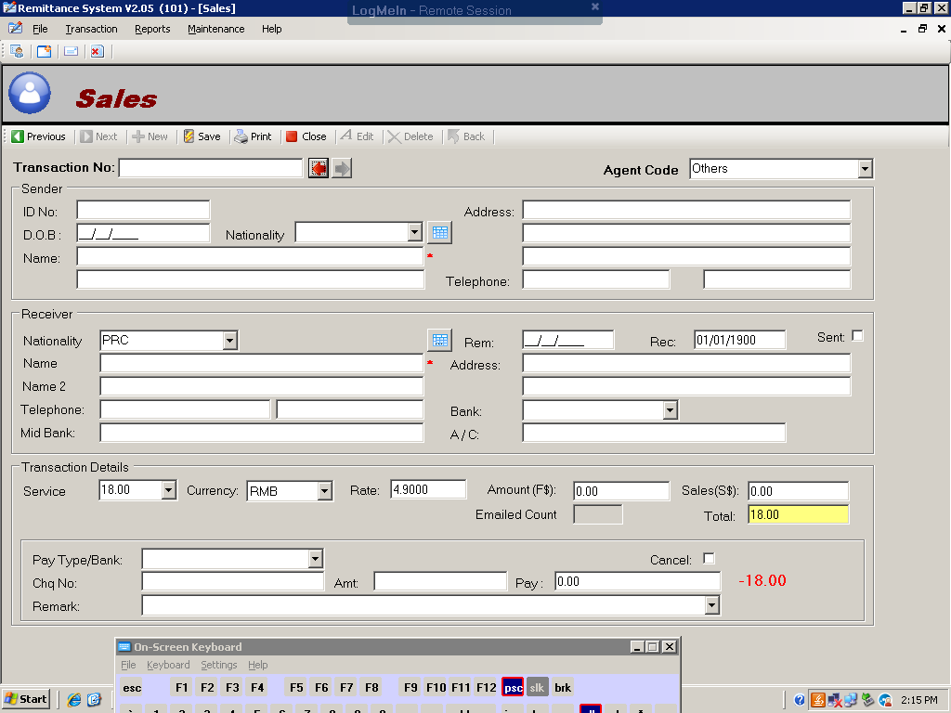

The search for new customer screen. The New button allows the user to create new customer.
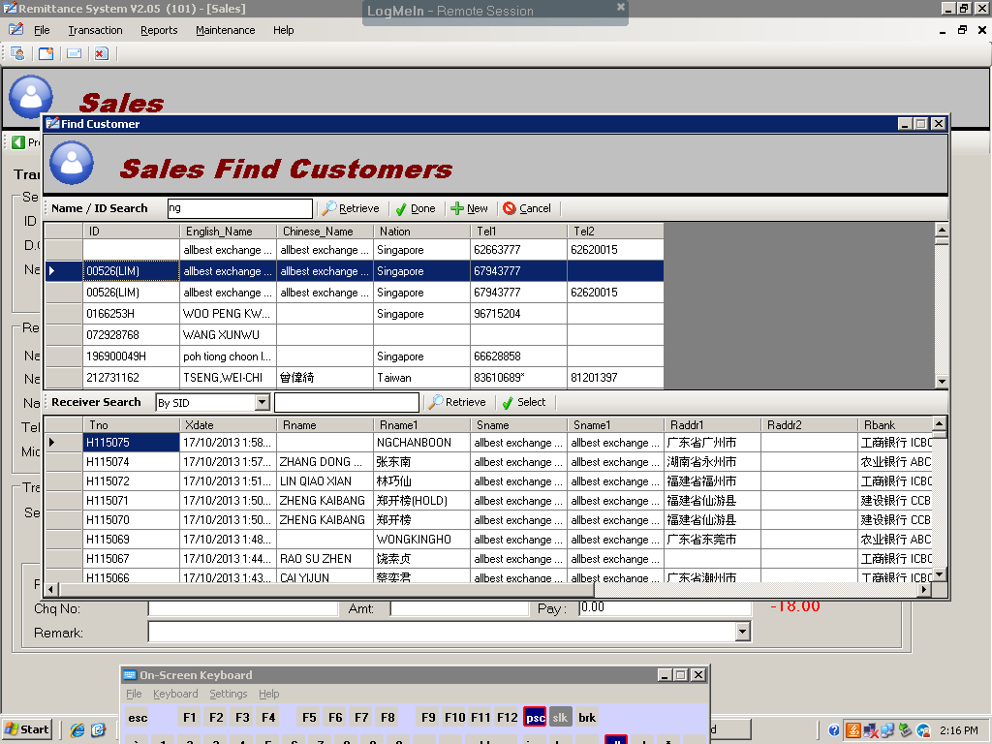

The email to agent screen. The selected transactions are saved as an excel attachment and sent through the user’s outlook express.
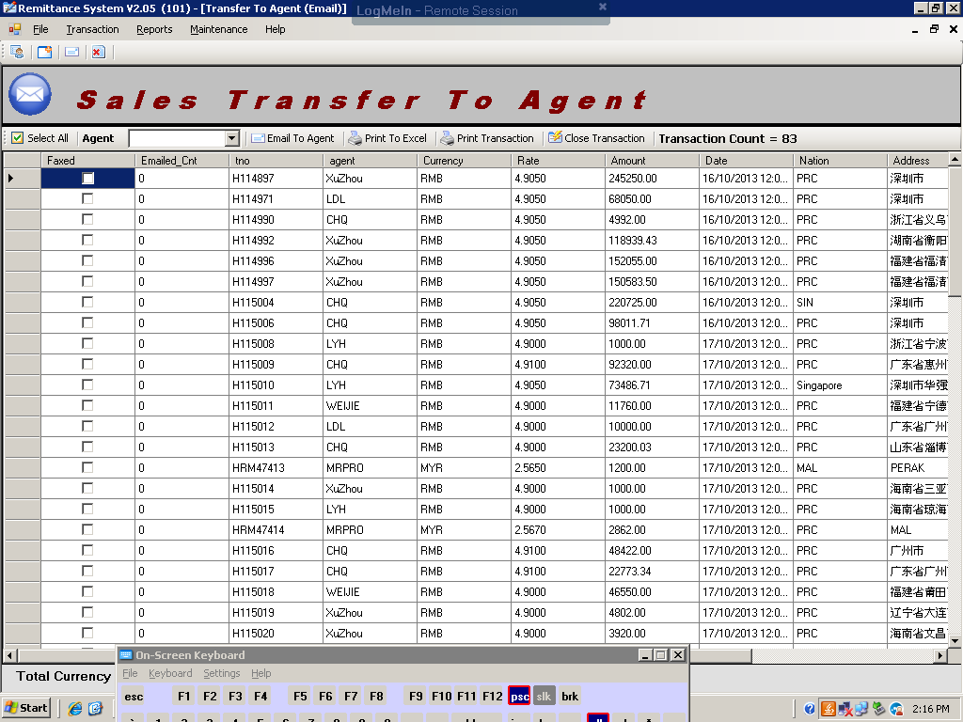

Allows user to see all open transactions. Allows user to edit the Agent field and update immediately.
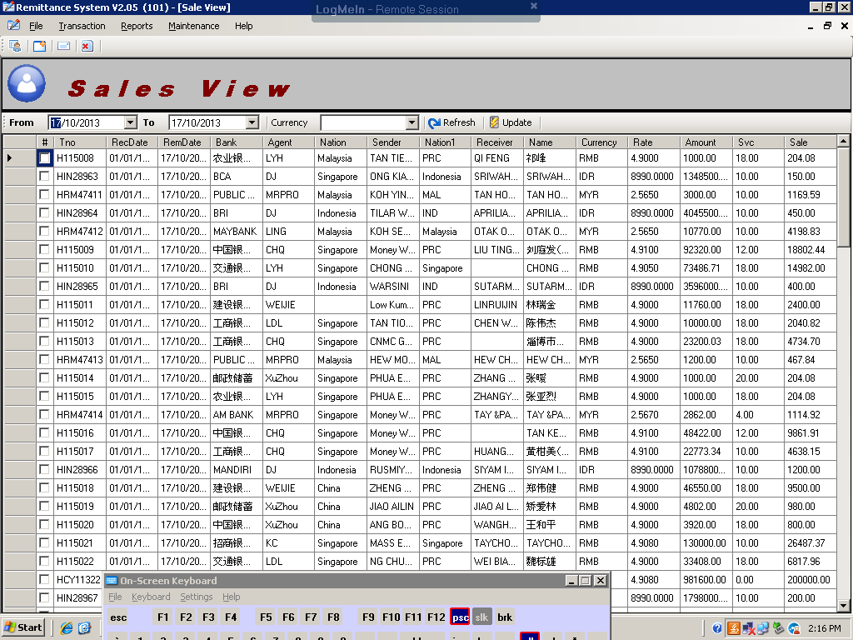
Allows user to update the Rec field and the RecDate.
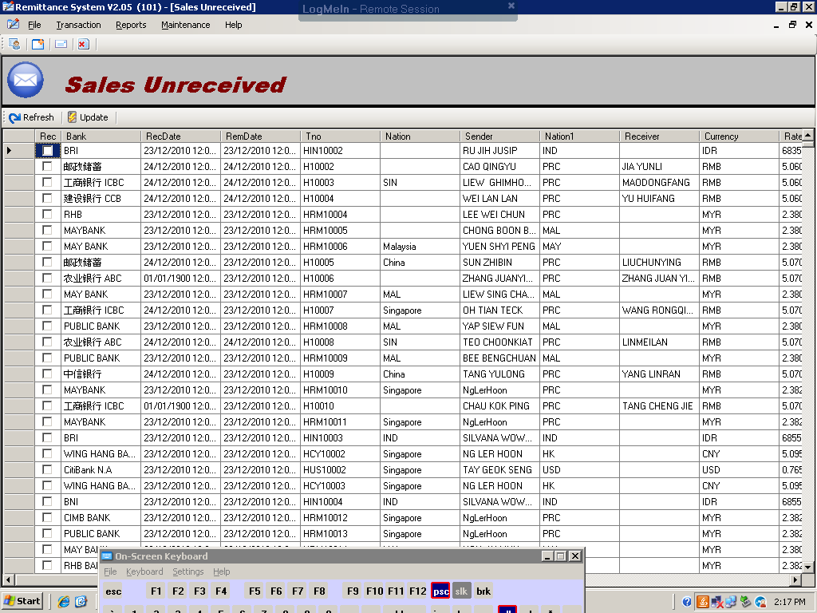

All the reports are required except for the Purchase portion.
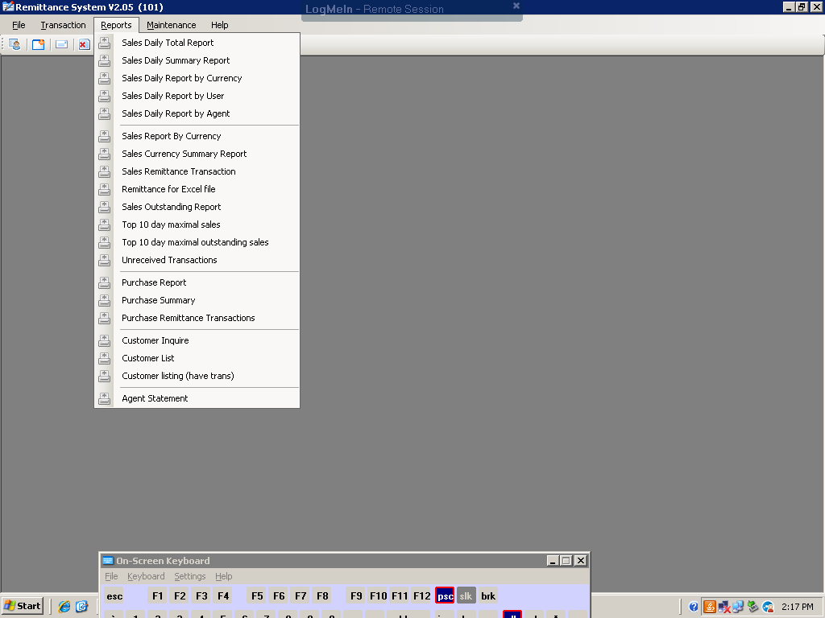

Sample of a report. Allows users to select the date range. By default would be today’s date.
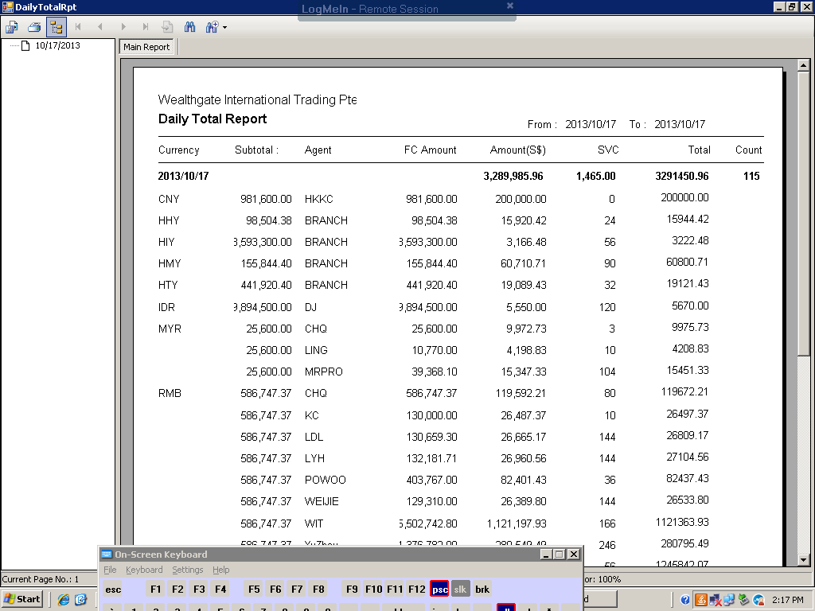

The parameters screens. All are required.
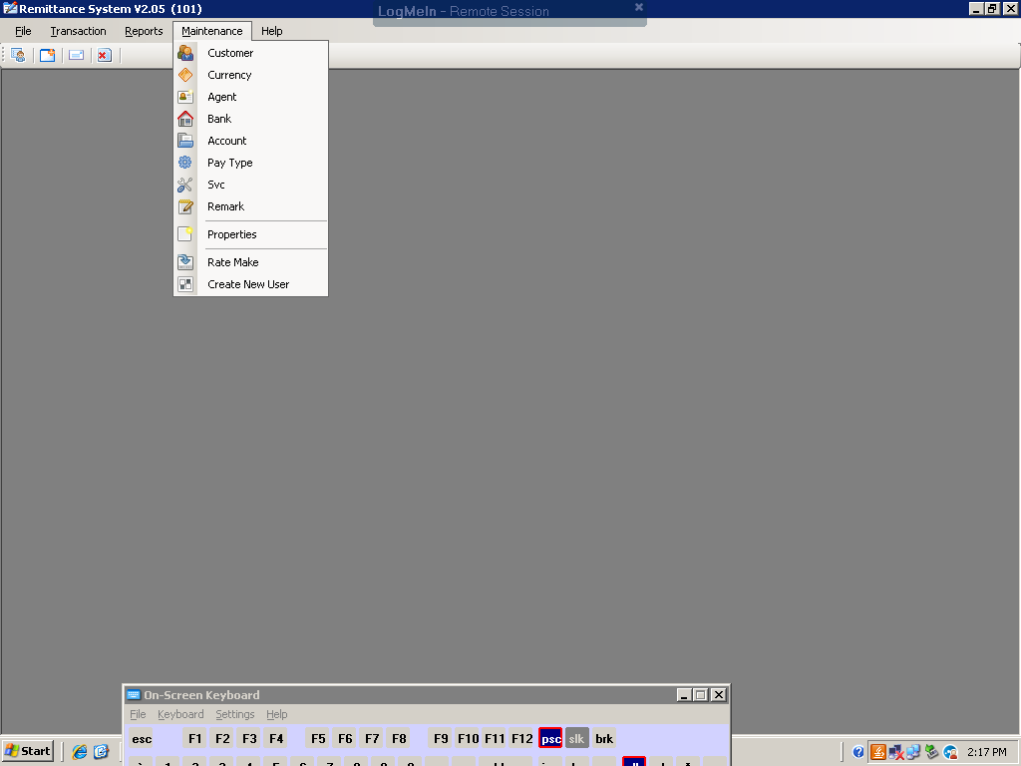

The customer screen.
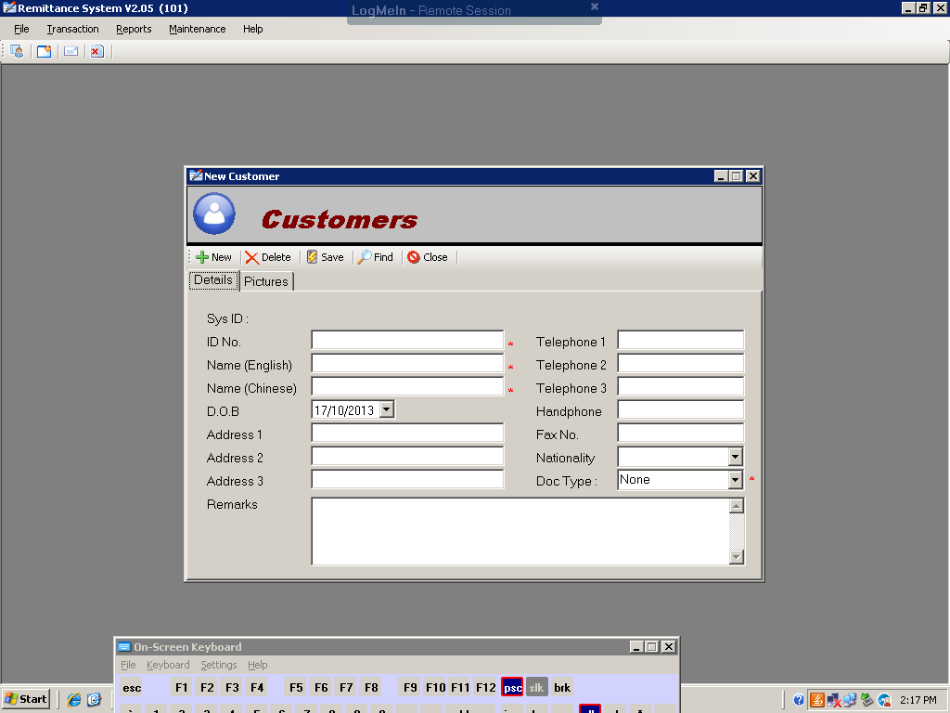

The currency screen for maintaining the currency rates in the sales transaction screen.
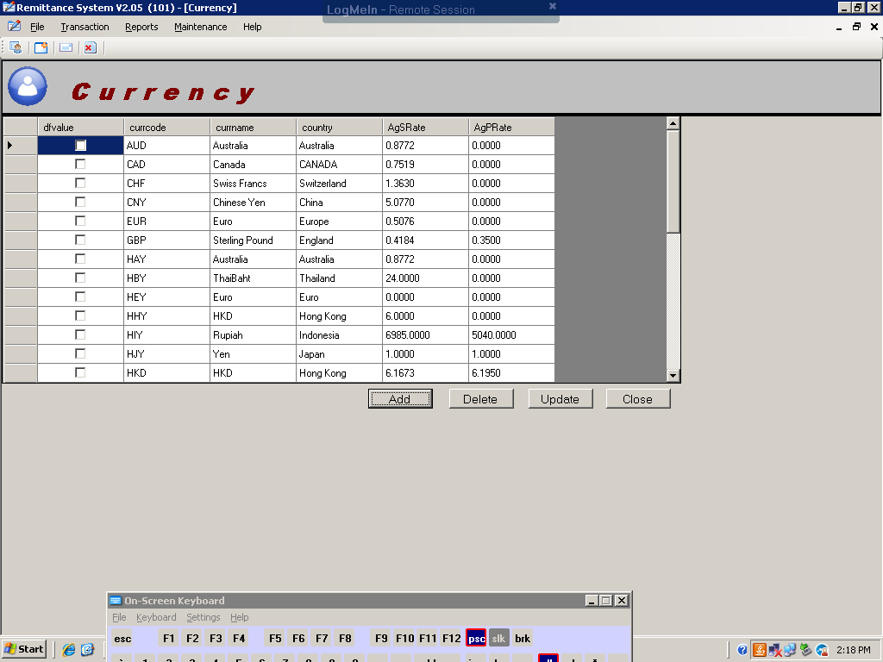

The Agent screen for maintaining the agent’s email address used in the email to agent screen.
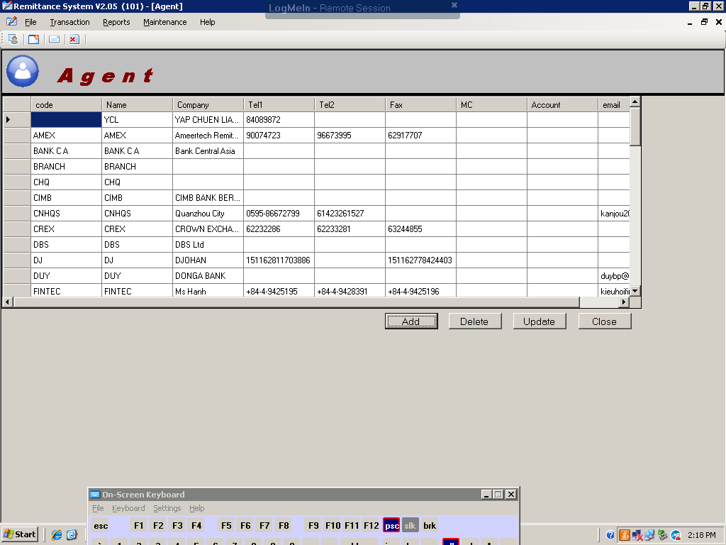

The screen for maintaining the running transaction numbers according to the currency type.
